**SECTION 4**

Collision Detection for BoxSplash Extension: **https://Happycoding.io/tutorials/processing/collision-detection**

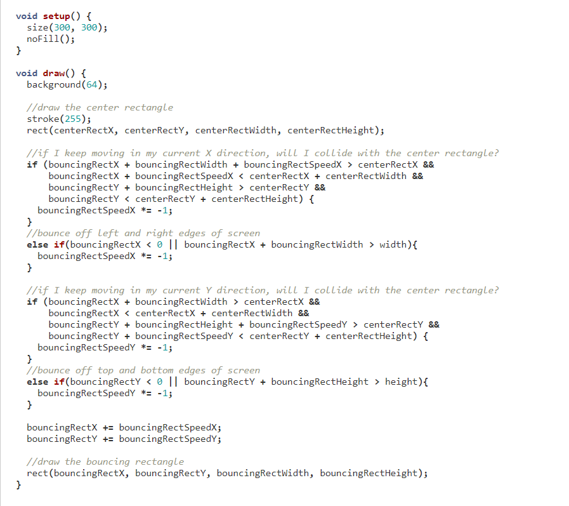

Translating Rings for Frequency Ring extension: <https://stackoverflow.com/questions/70917717/how-can-i-plot-4-vertexes-using-a-nested-loop/70917751#70917751>

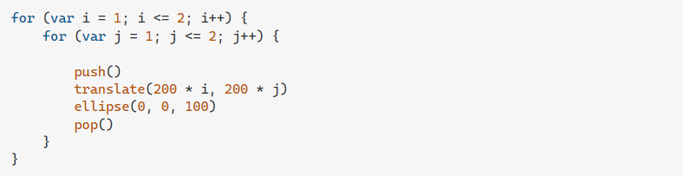

P5.Sound.JS and P5.Dom.JS were the only other extensions used.